Voice Based Concept Understanding Analyser

Entity Relationship Diagram
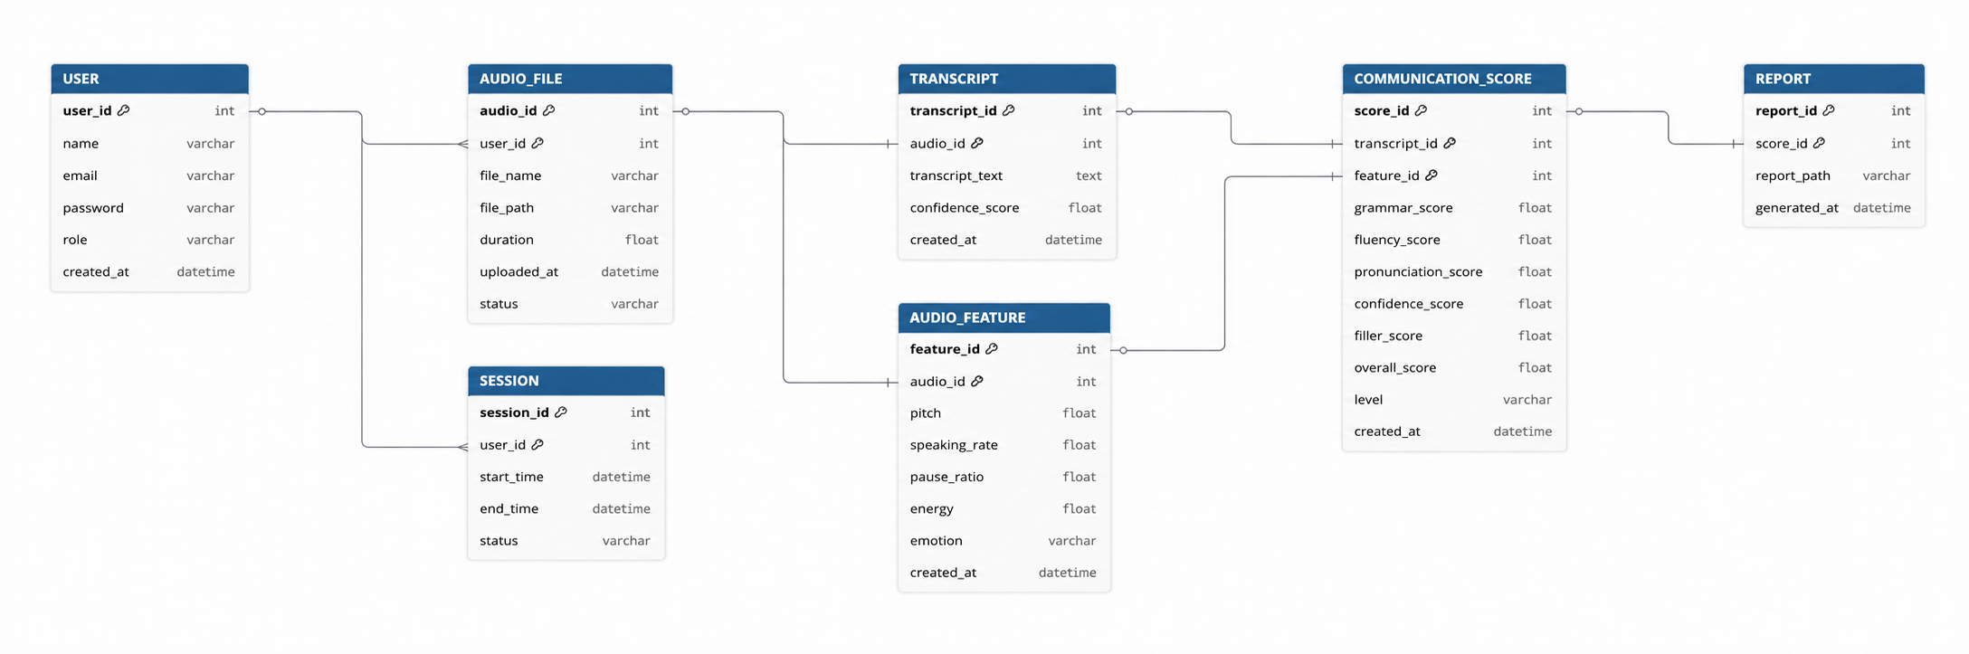

An Entity Relationship Diagram (ERD) is a graphical representation of the database structure that illustrates the entities, their attributes, and the relationships between them. It helps design a well-structured database, reduces redundancy through normalization, maintains data integrity, and simplifies database implementation.
For the Voice-Based Concept Understanding Analyser (VBCUA), the ER diagram models how users, uploaded audio files, transcripts, semantic analysis, audio features, evaluation results, and reports are connected within the system.
Main Entities: User, Audio File, Transcript, Audio Feature, Evaluation Result, Reference Concept, Semantic Similarity, Report, Session.
Key Relationships: Users upload audio files, which generate transcripts and audio analyses. These are evaluated against reference concepts to produce scores and reports.

